JWTD Assignment-5

Name: Lekha J

RollNo: 231047010

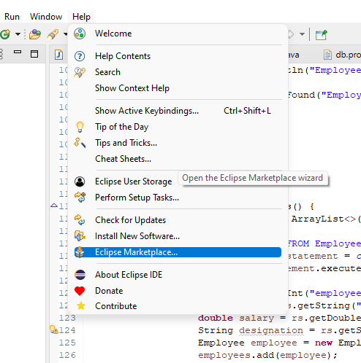

Search for: web application

Install the following

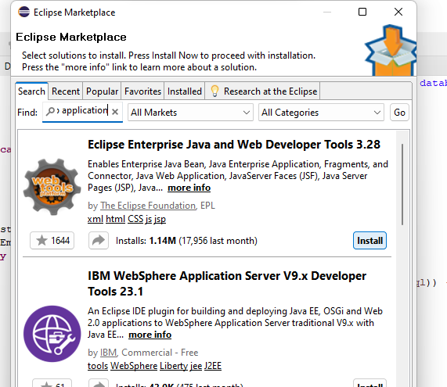

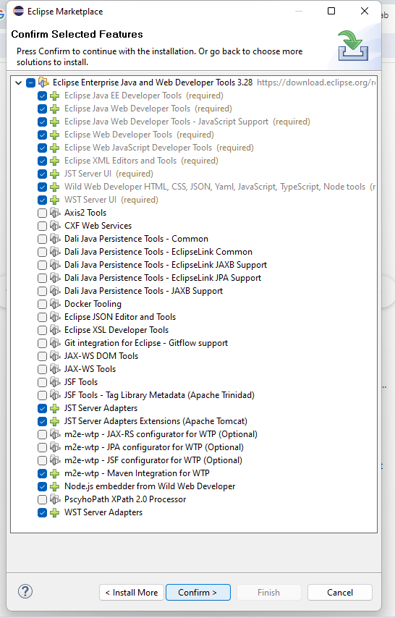

Click confirm. On the license page, click on I accept and then click Finish.

Wait for the software to get installed.

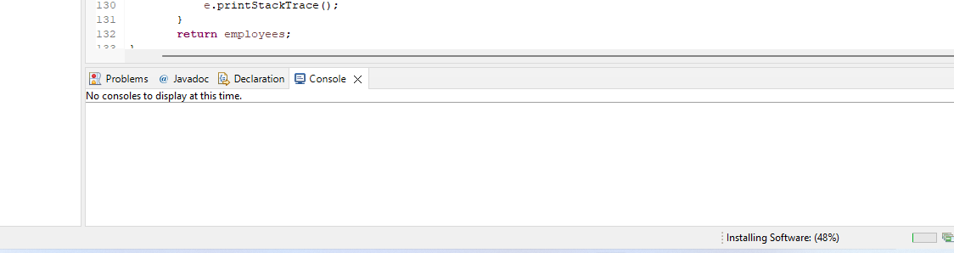

Restart eclipse once its installed.

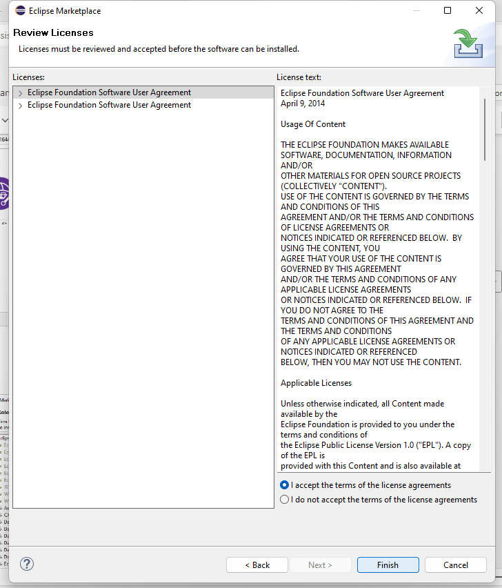

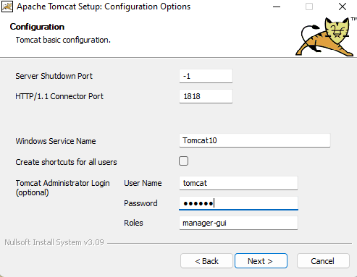

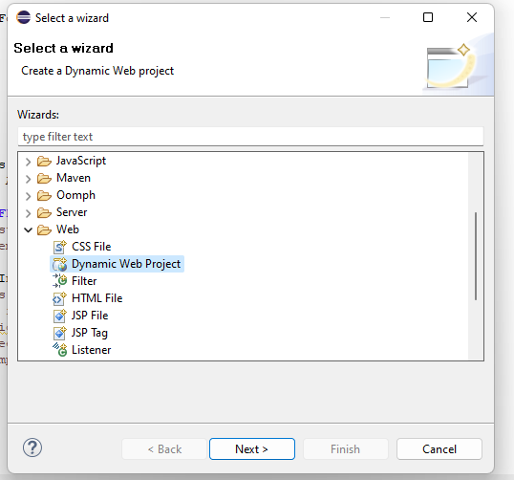

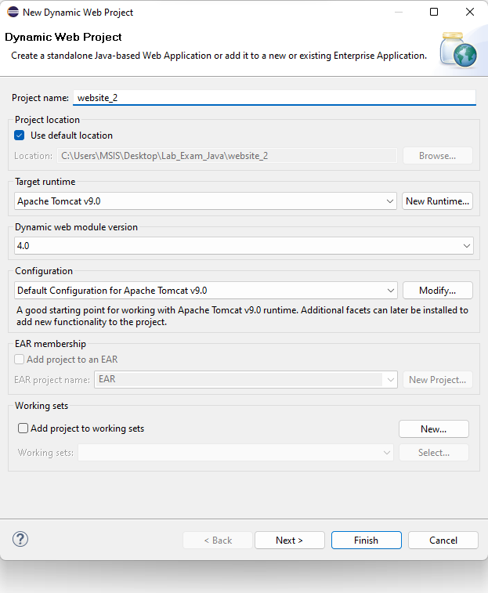

Html

<!DOCTYPE html>

<html lang=*"en"*>

<head>

<meta charset=*"UTF-8"*>

<meta name=*"viewport"* content=*"width=device-width, initial-scale=1.0"*>

<title>My Static Website</title>

</head>

<body>

<header>

<h1>Welcome to My Website</h1>

</header>

<nav>

<ul>

<li><a href=*"#"*>Home</a></li>

<li><a href=*"#"*>About</a></li>

<li><a href=*"#"*>Services</a></li>

<li><a href=*"#"*>Contact</a></li>

</ul>

</nav>

<main>

<h2>About Us</h2>

<p>This is a simple static website built using only HTML. It serves as an example of how to create a basic web page without any CSS styling.</p>

</main>

<footer>

<p>&copy; 2024 My Website. All rights reserved.</p>

</footer>

</body>

</html>

